Curtailment Analysis H1 2026
Grid constraints, Redispatch 2.0 and negative prices across the fleet
David Chen · 05 August 2026 · OPS-ANA-2026-03

1. Summary
In the first half of 2026 the fleet lost 42.6 GWh to curtailment, 3.4 % of the potential production of 1260 GWh (H1 2025: 2.6 %). Most of the curtailed wind energy is compensated – through the bid price in the UK balancing mechanism or through Redispatch 2.0 compensation in Germany. The growing issue is solar: during hours with negative prices our German solar parks receive no support payment and are switched off without compensation.
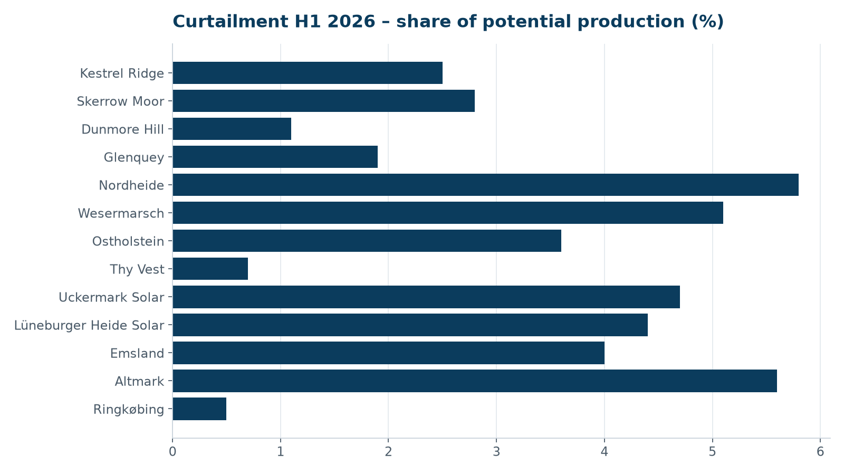

2. Asset view
Asset | Regime | Potential (GWh) | Curtailed (GWh) | Share | Compensated
Kestrel Ridge | UK constraint instructions | 113.6 | 2.8 | 2.5 % | Yes (bid price)
Skerrow Moor | UK constraint instructions | 128.9 | 3.6 | 2.8 % | Yes (bid price)
Dunmore Hill | UK constraint instructions | 79.4 | 0.9 | 1.1 % | Yes (bid price)
Glenquey | UK constraint instructions | 72.2 | 1.4 | 1.9 % | Yes (bid price)
Nordheide | Redispatch 2.0 | 128.2 | 7.4 | 5.8 % | Yes (compensation)
Wesermarsch | Redispatch 2.0 | 96.5 | 4.9 | 5.1 % | Yes (compensation)
Ostholstein | Redispatch 2.0 | 89.6 | 3.2 | 3.6 % | Yes (compensation)
Thy Vest | Danish TSO / market | 148.3 | 1.1 | 0.7 % | Partly
Uckermark Solar | Negative prices (§51 EEG) + Redispatch | 82.4 | 3.9 | 4.7 % | No (negative price hours)
Lüneburger Heide Solar | Negative prices (§51 EEG) | 51.7 | 2.3 | 4.4 % | No (negative price hours)
Emsland | Redispatch 2.0 | 102.7 | 4.1 | 4.0 % | Yes (compensation)
Altmark | Redispatch 2.0 | 121.9 | 6.8 | 5.6 % | Yes (compensation)
Ringkøbing | Danish TSO / market | 44.3 | 0.2 | 0.5 % | Partly

3. Redispatch 2.0 in Germany
Nordheide remains the most affected wind farm (5.8 %), mainly in March and February when high wind in the north meets limited transmission capacity towards the south. Compensation claims for Q1 were settled in June; the difference between our own calculation and the grid operator's figure was 3.1 % (EUR 41k), which we are disputing for Nordheide.

4. Negative prices and solar
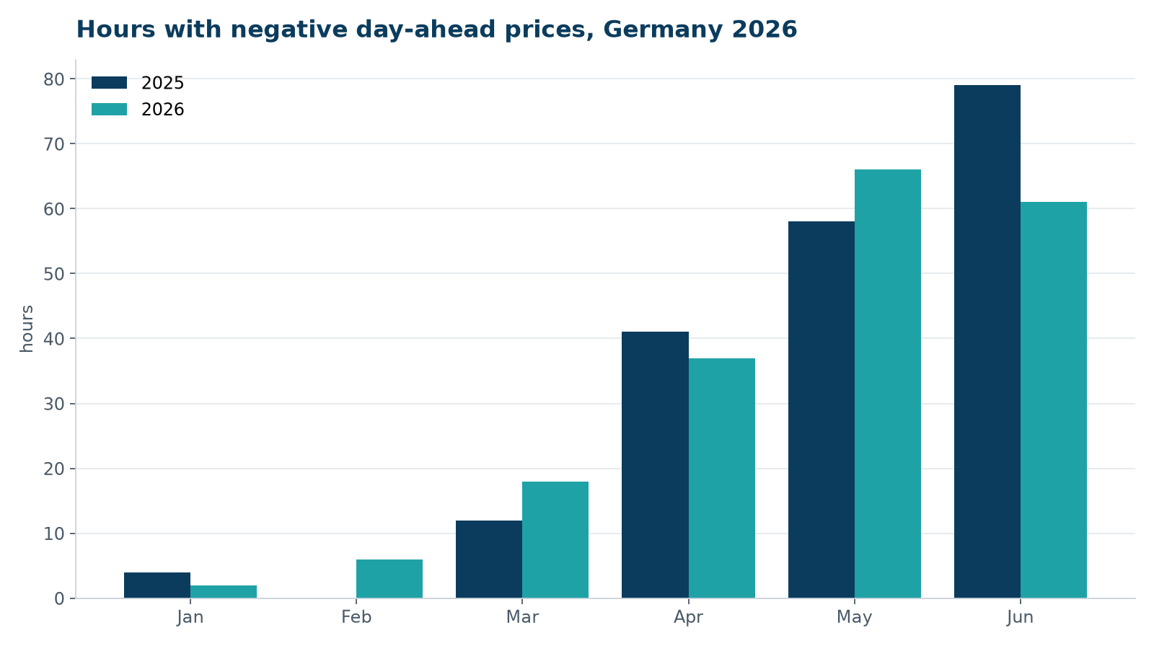
Germany saw 190 hours with negative day-ahead prices in H1 2026 (H1 2025: 194). For plants commissioned after 2016, the market premium is not paid during these hours. Uckermark and Lüneburger Heide therefore curtail automatically when the price is below –EUR 0.50/MWh. The lost energy (6.2 GWh) has little economic value; the real lever is storage. A co-located battery at Uckermark (20 MW / 40 MWh) is being assessed by Kwame Mensah's team.

5. UK constraints
Kestrel Ridge was curtailed on 31 occasions in H1 2026 (2.8 GWh, 2.5 %), almost all during high-wind periods in January to March when the transmission network across the Scottish border is congested. Revenue from constraint payments covered about 92 % of the lost market revenue.

6. Recommendations
- Dispute the Nordheide Q1 Redispatch settlement (EUR 41k).
- Feasibility study for co-located storage at Uckermark (decision Q1 2027).
- Improve forecasting of constraint instructions for Kestrel Ridge and Skerrow Moor with the trading desk.
- Report curtailment as a separate KPI in the Fleet KPI Dashboard from 2027.

